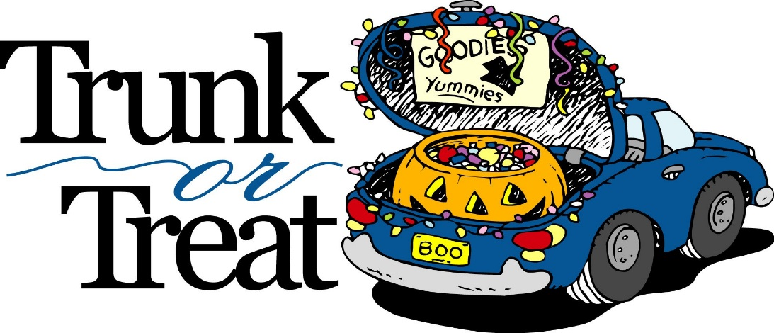
1st Halloween Celebration for the Whole Family Sponsored by Gretna Post Prom and the Gretna Area Chamber of Commerce

October 27th from 4-7 at the Gretna High School back (east) parking lot

Cost is $5 per child for a wristband

Wristband includes: Trick or Treating, Live DJ (with costume and dance contest), Bouncy Houses, and Glitter Tattoo’s.

Food Trucks will be available for an additional cost

Purchase your wristbands today so you don’t have to wait in line. Please fill out the information below and send back to your school office with payment by Wednesday Oct 24th. Wristbands will be delivered on Thursday, Oct 25th to your child’s school and sent home in their Friday folder. Wristbands will also be available to purchase at the event.

____ _____For Questions call Jennifer @ 402-203-0888 _______________

Childs Name _________________________________________

School _____________________________________________

Teacher _____________________________________________

# of Wristbands _______________ Total $_________________

